IVITATION
HOMOKHÁTI JONATHERMÁL CUP
Papp János Memorial Event
Great preparationfor JWOC 2018!

3-DAYORIENTEERING EVENT
FISCHERBÓCSA
19-21th MAY 2018.(saturday - monday)
Organizer:
The Orienteering Section of Maccabi Fencing and Athletic Club
Event’s main patron:
Zsolt Patkós
Mayor of Szank
Event’s main sponsors:
Municipality of Szank
Municipality of Kiskunmajsa
Jonathermál Spa, Motel, Camping
KEFAG - Kiskunsági Erdészeti és Faipari ZRt.
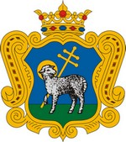 |  |  | 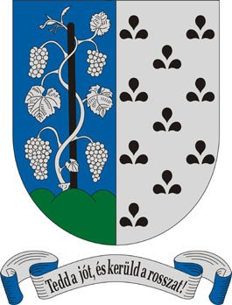
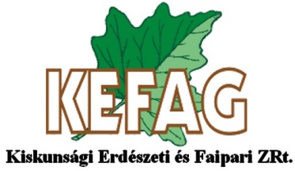

ORGANIZERS:
The Orienteering Section of Maccabi Fencing and Athletic Club
Telefon: +36-30-2068535
Email: paskujm@gmail.com
Web: www.tajfutas.maccabi.hu

Organizers
President | Mátyás Paskuj
Secretary | Norbert Bozsó
Coursesetters | Miklós Forrai, Gábor Forrai, Kornél Szőri
Controller | János Spiegl
SportIdent | Sándor Ambrus, Ádám Petróczki

FORM OF THERACE
Homokhati Jonathermal Cup: 3-day, 3-stage, individual national ranking race.
1-stage, night, individual national rankin grace.
Homokhati Jonathermal relay:2 x 2runners, national ranking relay.

PROGRAMME
 |  |  | Race | Coursesetter | Controller
Saturday 19th May | 14:00 | stage 1 | middle distance | Kornél Szőri | János Spiegl
Saturday 19th May | 22:00 | night | middle distance | Miklós Forrai | János Spiegl
Sunday 20th May | 10:00 | stage 2 | middle distance | Kornél Szőri | János Spiegl
Sunday 20th May | 13:00 | relay |  | Gábor Forrai | János Spiegl
Monday 21st May | 10:00 | stage 3 | long distance | Kornél Szőri | János Spiegl

MAP
reviewedin 2015-18, 1:10000, 1:7500 scale, 2 m contours.
night: 2018, 1:5000 scale, 2 m contours.
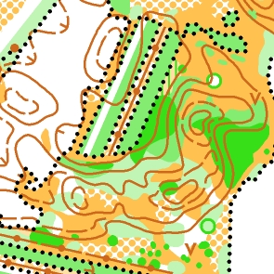 | 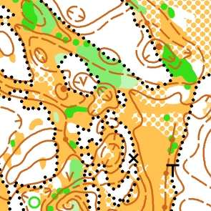 | 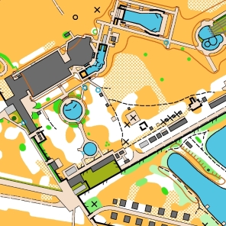

TERRAIN
Open and semi open areas with sand hills, mostly good runnable pine forest swith some green area. Moderate path density.
Night race: Recreation are a with parks and paved roads.

CATEGORIES
Jonathermal Cup (3-stage race): M/W 10D, 10DK, 12C, 14B, 14C, 15–18C, 16B, 18B, 20A, 21A, 21B, 21Br (short), 21C, 35A, 35Br (short), 40A, 45A, 45Br (short), 50, 55, 60, 65, 70, 75, M80, 85 Open beginner, Open advanced short, Open advanced long,
Children’s race.
Night: M/W 18B, 20A, 21A, 21Br (short), 35A, 45A, 55, 65, Open beginner
Relay: 2 x 2 (2runners): N/W 14, 18, 21,35, 50, MIX
Categories may be merged.
RESULTS
Overall results for the 3-day event. The Night-O and the Relay will be awarded separately.
PRIZES
Medals and awards will also be presented to all categories’ top 3 of 3-days race.
Papp János Memorial Event: 3rd day winner of category M45A will be rewarded with a cup offered by municipality of Ruzsa.
The winners of relay and night races will receive medals.

ENTRY
Entry: via MTFSZ ENTRYhttp://nevezes.mtfsz.hu/
Orienteeringonline: http://www.orienteeringonline.net/CompetitionSearch.aspx
By e-mail: nevezes@maccabi.hu
All e-mails will be answered within two days. In case of no reply please resend your e-mail
entry. Please specify the following data with each entry: club, name, category, date of birth,
SI number if any.

ENTRY DEADLINES AND FEES
Deadline | M/W-18 és 60- |  | M/W 20-55 |  | Night | Relay
 | 1 race | 3 races | 1 race | 3 races
until 22 nd Apr 2018 | HUF 1400 | HUF 3400 | HUF 2100 | HUF 5600 | HUF 1300 | HUF 2600
until 6 th May 2018 | HUF 1600 | HUF 4300 | HUF 2400 | HUF 6100 | HUF 1500 | HUF 3000
after 6 th May 2018 | HUF 1900 | HUF 4900 | HUF 2700 | HUF 7100 | HUF 1800 | HUF 3600
SI rent: HUF300 /race(free for M/W10–14)
Open categories:every race HUF 1500 at any time.
Everyrunnergets 50% discount ticket to Kiskunmajsa Jonathermal Spa and
Adventure centre (from 19th Maj 2018 to 21st Maj 2018)

ACCOMODATION
Motel, wooden house, holiday house, guest house, camping next to the spa:
http://www.jonathermal.hu
Accomodations are managed individually, telephone:+36-77-481855, e-mail: info@jonathermal.hu

Gymin Szank: HUF 1000 /person / night

Sport Motel: HUF 3000 /person / night (only 34 person)

PAYING
Cash at the event center or bank remittance according to the entried runners.
Payment of entry fee and accomodation by bank transfer until 15 May 2018:
Bank name & address:UniCredit Bank Hungary Zrt, 1054 Budapest, Szabadság tér 5-6.
IBAN: HU14 1091 8001 0000 0093 6118 0008
Account holder: Maccabi Fencing and Athletic Club Orienteering Section
BIC/SWIFT code: BACXHUHB
Comment: Homokhati Jonathermal Cup 2018 and your (your club’s) name

In case of bank transfer please send an e-mail with details (names, club, sum).

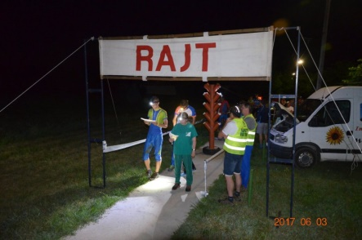 | 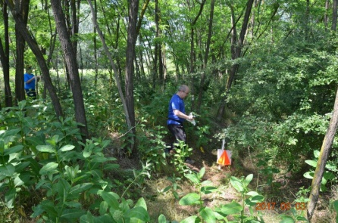 | 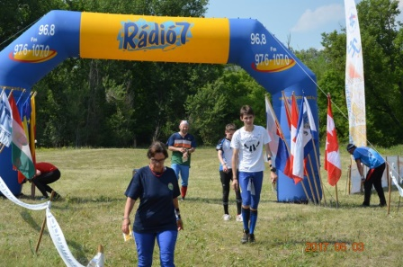

TRANSPORTATION
Public transport is available, but if required, transportation can be organised if your request is received until 30 May.

PARKING
HUF 500/3 days, HUF 200/day.

OTHERS
SI punching system will be used.
Any trading in the competition area during the event is only allowed with the permission of the president of the Organizing Committee.
In the Finish area cold and hot meals will be served all three days.
All competitors start at their own risk.
Otherinformation: paskujm@gmail.com
Website of the competiton: http://tajfutas.maccabi.hu/index.php/en/homokhat-maccabi-kupa-2018
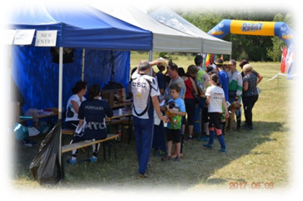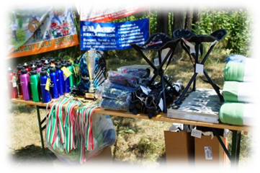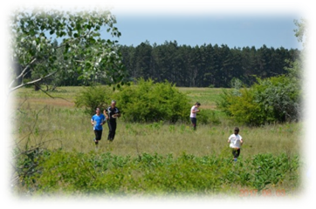We hope to see you at Homokhati Jonathermal Cup 2018!

