INVITATION
HOMOKHÁTI HUNGÁRIA CUP
5 DAYS INTERNATIONAL ORIENTEERING COMPETITION
MÓRAHALOM - SUBOTICA
16th - 20th August 2019 (Friday - Tuesday)
Organizer:
Maccabi VAC commissioned by the Hungarian Orienteering Association
Main patrons:
Béla Kakas President of the General Meeting of Csongrád County
Zoltán Nógrádi Mayor of Mórahalom

Other patrons of the competition:
János Lázár Parliamentarian
Sarolta Monspart Orienteering World Champion
Ferenc Sulyok Officer of Kiskunsági Erdészeti és Faipari Ltd.

Main sponsors:
Council of Csongrád County
Council of Mórahalom
Szent Erzsébet Thermal Spa Mórahalom
Móra-Sport Rekreációs és Sportszervező Non-profit Ltd.
KEFAG- Kiskunsági Erdészeti és Faipari Ltd.

Organizer:
Orienteering Section of Maccabi Fencing and Athletic Club
Telefon: +36-30-2068535
Email: paskujm@gmail.com
Web: www.tajfutas.maccabi.hu

Organizers
President | Mátyás Paskuj
Vice-President | Zoltán Miháczi
Secretary | Sándor Ambrus
SportIdent | András Ambrus

 | Course Setters | Controllers
- day | Zoltán Miháczi | Dávid Marosán
- day | Zoltán Miháczi | Mónika Tokaji
- day | Miklós Forrai | Ádám Lengyel
- day | Gábor Forrai | Gergely Bugár
- day | Miklós Forrai | János Spiegl

Form of the competition: 5-stages, individual sprint ranking competition with overall
results. On the 5th day with chasing start

Competition Centre: Mórahalom, Móradombi Sportcsarnok
Adress: 6782 Mórahalom, Móradombi körút

Categories: M/W 10D, 12C, 14B, 14C, 16B, 18B, 15-18C, 20A, 21A, 21B, 21Br, 21C, 35A, 35Br, 40A, 45A, 45Br, 50A, 55A, 60A, 65A, 70A, 75A, + M80A,
Open, M/W10DK
Categories might be merged.

Detailed program:
Date | Time | Location | Distance
15th August Thursday | 14:00 | Ásotthalom | training
16th August Friday | 10:00 | Kisszállás | long distance
17th August Saturday | 10:00 | Kisszállás | middle distance
18th August Sunday | 14:00 | Subotica (Serbia) | sprint distance
19th Augusztus Monday | 10:00 | Balotaszállás | long distance
20th August Tuesday | 10:00 | Balotaszállás | middle distance with chasing start

LOCATIONS:
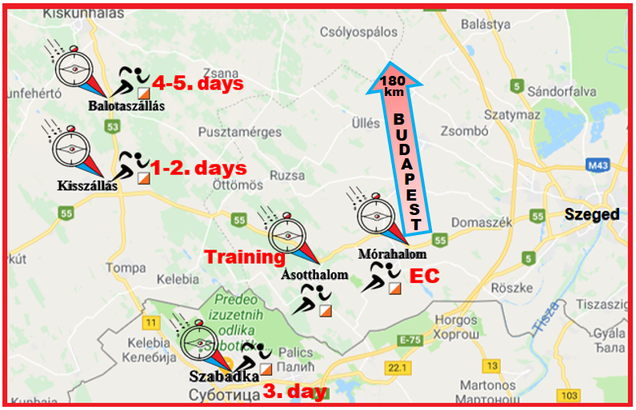

ENTRY DEADLINES AND FEES

Entry deadlines: | M/W -14 and 65- |  | M/W 16-60 |  | Open , 10D, 10DK
 | 1 day | 5 day | 1 day | 5 day | 1 day | 5 day
Until 31st May 2019  Payment deadline:  1st July 2019 | 8  EURO | 40 EURO | 12 EURO | 60 EURO | 8  EURO | 40  EURO
28th July 2019  Payment deadline:  31st July 2019 | 10 EURO | 50 EURO | 14 EURO | 70 EURO
After 28th July 2019  Payment deadline  Immediate payment | 12 EURO | 60 EURO | 16 EURO | 80 EURO | 8 EURO | 40  EURO

Other fees: SI rent (14+): 1 EURO/person/day
Parking fee: 1 EURO/day, for 4 days 3 EURO (1-2, 4-5. days)

Entry: online: ENTRY: http://nevezes.mtfsz.hu
ORIENTEERINGONLINE: http://orienteeringonline.net
e-mail: hungariacup@mtfsz.hu

Payment must be done until the given deadline by bank transfer!
Once payment is completed, we finalize your registration.

Attention! When you make the bank transfer please do not forget to
write us your name and club!

Bank Account Number: Bank name & address:UniCredit Bank Hungary Zrt,
1054 Budapest, Szabadság tér 5-6.IBAN:
HU19 1091 8001 0000 0093 6118 0015
Account holder: Maccabi Fencing and Athletic Club
Orienteering Section
BIC/SWIFT code: BACXHUHB

Accomodation: Temporary camping in the gym hall of Mórahalmon
4 EURO/person/day. The price includes the shower and toilet services.

For other accomodation please check the website: http://www.erzsebetfurdo.morahalom.hu/hu/szallashely/

We highly recommend you to book your accommodation in this year because the number of the accommodation is limited!

Terrain: 1-2, 4-5. days: Sandy forest with different runnability and open areas.
Different density of the vegetation, at some places with groves and junipers.
3. day: Urban environment with different built-in features and different density
of road network. At some places with large parks and playgrounds.
Mostly solid enclosure, excellent runnability.

Maps: 1-2, 4-5. days:scale: 1: 10 000, 1 : 7 500, contour details:2 m.
3. nap: scale: 1: 4000, contour details:1 m.

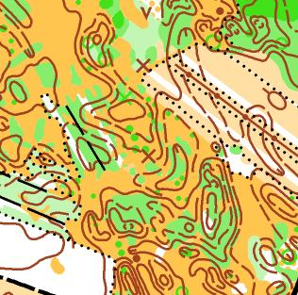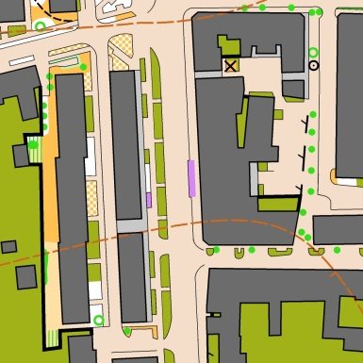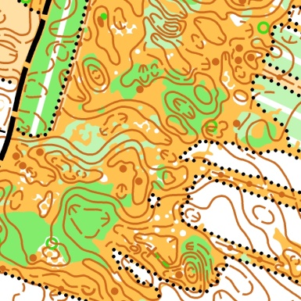

The maps are checked up and corrected in 2018/19

Training: 15th August 2019 (Thursday) from 2 pm there is training opportunity in
Ásotthalom (There is no SI)

Child competition: Every day nearby the finish area

Kindergarden: Every day nearby the finish area there is a kindergarden with
permanent childcare.

Prizes: On the first 4 days the winner are getting a yellow t-shirt. On the 5th day
according to the overall results of the 5 days the first tree competitiors of every
category get medals and honorarium.

Accompanying competitions: Night, Orienteering with mobiles, TrailO, Radio Direction
Finding, orientation hiking, Microsprint, Beer-relay

Others: Every competition day there is Free entrace to the Szent Erzsébet
Thermal Bath Mórahalom between 5 pm and 10 pm!
We use SI system during the competition.
The 3rd day is held in Subotica, Serbia. Attention Serbia is not member of EU.
To be able to cross the border, please take your passport and
visa (if needed) with you!
Commercial activity only can be done with the persmission of the organizer.
Every day there is buffet nearby the finish area.
Competitiors take parton their own risks!

For more information: paskujm@gmail.com

Website of the competition http://hungariakupa.tajfutas.hu

WE HOPE TO SEE YOU IN HUNGARIA CUP 2019!
Sponsors:

